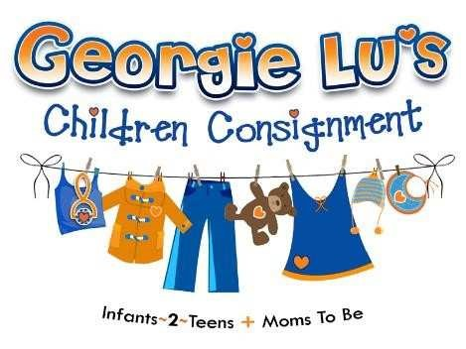
Donna Evans
7540 Main Street, Suite 10
Sykesville, MD 21784
Direct: (443) 920-3146
Fax: (410) 875-7963
Georgielus@gmail.com
Georgieluschildrensconsignment.com
CONSIGNOR AGREEMENT:
Consignor Name _____________________________Consignor ID_________________
Address________________________________________________________________
City__________________________________________ State_________ Zip_________
Phone_________________________ E-Mail Address _____________________________ We are pleased to welcome you to the Georgie Lu’s consignment family!
When you bring your items in to consign, we will approve which items will be sold. If an item does not meet our standards for cleanliness or appropriateness the item will be donated to a non-profit of our choice. We have our consignors and customers best interest in mind and want to offer the best items for purchase.

We calculate prices based on supply and demand. We will do our best to get the best prices for your items.

You will receive 40% of the selling price (prior to handling fee) for clothing and 50% for large baby equipment.
- Checks will be mailed the first week of January, March, May, July, September and November and will include any items sold in that billing cycle.
- $2.00 is withheld from your check to help defray expenses incurred in merchandising.
- Account balances below $10.00 will roll forward to the next billing cycle.
Page 1 of

2

Once items are approved for sale, they will be entered into our system and your account. We will send an email with your consignor number.

- We will display your items for 90 days.
- You can check your items that have sold and the amount they were sold for at www.info.myconsigns.com by entering your consignor number and last name.
- If you want your unsold items back, stop in before the expiration date and find your items in the store.
1. You are responsible for finding your items, taking them off the hanger and handing the tags in for verification.
2. If you do not pick up your items before the expiration date the items become the property of Georgie Lu’s Consignment.
- There are exceptions for seasonal items: Seasonal items that have been stored away cannot be guaranteed for pick until the designated season. If you have seasonal items you would like to pick up, please notify us in advance and we will let you know when the items are available for pick up.

If an item is found to be on the Consumer Product Safety Recall List, you will be notified, the item will not be able to be consigned.
We are not responsible for loss or damage but will do our best to safeguard every item that enters our inventory.
We reserve the right to terminate your consignment with us if you regularly bring in items that do not meet our guidelines as indicated previously.

I have read the above terms and agree to accept them.

Signature: _____________________________________

Date: _________________________________________

We look forward to a long and mutually profitable relationship with you

Page

2

of

2

